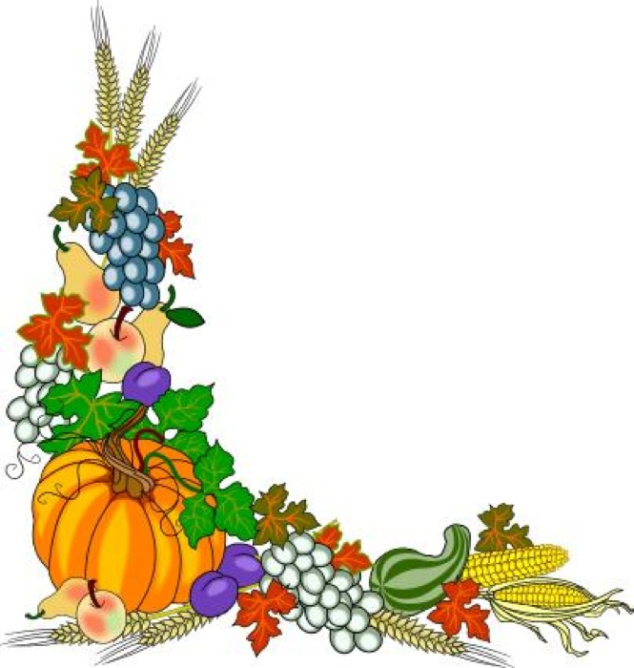

**Raffle at Sunset**

**$1000 Grand Prize**

**Super Raffle to Follow**

Gourmet Hamburger Bar, French Fries and Beverage $10.00

Burgers from Schiefelbein Farms

Ice Cream Bar

Beer Garden

Craft Sale

Silent Auction

Talent Show

**September 18**

**Join us for Mass at 5 p.m.**

**Festival to Follow**

**St. Anne’s Fall Festival**